REPORT OF THE PLAGIARISM CHECK

THIS REPORT CERTIFIES THAT THE ATTACHED WORK

***Plagiarism Checker***

WAS CHECKED WITH THE PLAGIARISM PREVENTION SERVICE MY.PLAG.AI AND HAS:

SIMILARITY

0%

RISK OF THE PLAGIARISM

1%

PARAPHRASE

0%

IMPROPER CITATIONS

0%

File name: @CPE - Research Paper.docx

File checked: 2024-04-09

Report generated: 2024-04-09

**SnX (3D Outfit Customizer)**

*Abdurrahman Qureshi, Oaish Qazi, Hussain Shaikh*

*Department of Computer Engineering*

*M.H.Saboo Siddik Polytechnic,Byculla,India*

scythethroughtheheart05@gmail.com

oaishqazi@outlook.com

hussainshaikh@gmail.com

***Abstract*—The "3D Outfit Customizer" project introduces a groundbreaking initiative aimed at revolutionizing online fashion shopping by integrating Next.js, React, MongoDB, and Three.js technologies. This endeavor seeks to empower users with unparalleled levels of customization and personalization, bridging the gap between traditional in-store experiences and online browsing. Through the development process, challenges faced, and potential implications, this paper explores the transformative impact of this innovative approach on the fashion industry.**

**Keywords: Three.js; React.js; Next.js; 3D; Outfit**

**I. Introduction**

The "3D Outfit Customizer" project represents a ground-breaking initiative aimed at transforming the online fashion shopping landscape. By harnessing cutting-edge technologies including Next.js, React, MongoDB, and Three.js, this project seeks to empower users with unparalleled levels of customization and personalization. Traditional online shopping experiences often lack the immersive and interactive elements found in physical stores, leading to a disconnect between users and the products they browse. However, with the advent of the "3D Outfit Customizer," users can now engage in a virtual shopping experience that mirrors the tactile nature of in-store shopping while enjoying the convenience of online browsing. This paper delves into the development process, challenges faced, and potential implications of this innovative approach in revolutionizing the fashion industry.

**II. Development Process**

The development of the "3D Outfit Customizer" project involved the integration of several key technologies to create a seamless and immersive user experience. Next.js was chosen for its server-side rendering capabilities, ensuring fast page loads and enhanced search engine optimization. React played a pivotal role in building reusable UI components, facilitating a smooth and responsive interface. MongoDB served as the database backend, enabling efficient storage and retrieval of user preferences and customization data. Three.js emerged as the cornerstone of the project, providing the framework for rendering lifelike 3D models and creating a realistic virtual environment where users could interact with their customized outfits in real-time.

**III. Implications and Future Directions**

The implications of the "3D Outfit Customizer" project extend far beyond the realm of online fashion shopping. By offering users unprecedented levels of personalization and interactivity, this project has the potential to revolutionize the way consumers engage with fashion brands and products. The immersive nature of the virtual environment opens up new avenues for marketing, brand engagement, and customer loyalty. Looking ahead, future iterations of the "3D Outfit Customizer" could incorporate advanced features such as AI-driven recommendations, augmented reality integration, and social sharing functionalities, further enhancing the user experience and cementing its position as a game-changer in the fashion industry.

**IV. Literature Review**

Technological advancement has accelerated the growth of online commerce, and e-commerce platforms continue to strive to improve customer experience. Personalization and interactivity have become important factors that increase customer engagement and satisfaction in the online shopping environment. Research shows that consumers are more likely to buy from platforms that offer personalized and interactive recommendations, such as virtual testing and convenient repair tools. The fashion industry in particular has seen an increase in the use of [(gi.org)](https://gi.org/guideline/screening-and-surveillance-of-the-early-detection-of-colorectal-cancer-and-adenomatous-polyps/) 3D visualization and customization tools that allow users to search for products in a better and more realistic way. This tool allows users to personalize their clothing and accessories, providing greater interactivity and personalization.

**V. Existing Research**

Research on the use of Next.js, React, MongoDB, and Three.js in web development and virtual environments has shed light on their capabilities and potential applications. Next.js, with its server-side rendering capabilities and SEO benefits, has become increasingly popular for building fast and efficient web applications. React, known for its component-based architecture and reusability, has revolutionized front-end development by offering developers a more streamlined approach to building user interfaces. MongoDB, a NoSQL database, provides flexibility and scalability, making it well-suited for storing and managing large volumes of data in web applications. Three.js, on the other hand, is a powerful library for creating 3D graphics and animations in web browsers, enabling developers to build immersive virtual environments with ease.

**VI. Implications and future directions**

The integration of Next.js, React, MongoDB and Three.js in the development of an online store is promising for improving users' knowledge and business development. Using this technology, developers can create a fluid, interactive environment that mimics the business world. Additionally, developing seamless integration of online and offline shopping channels through technologies such as augmented reality and virtual reality will enable a truly immersive experience. We are paving the way for an omni-channel shopping experience.

**VII. Project Overview**

The "3D Outfit Customizer" project is a web-based application that aims to revolutionize the online shopping experience. (Edgeryders.eu) Leveraging a combination of Next.js, React, MongoDB and Three.js, the project aims to offer users a highly immersive and customizable platform for clothing and identity selection. Next.js was chosen for its external rendering capabilities that speed up page load times and improve search engine optimization (SEO). This allows users to access the application quickly and efficiently, while also increasing its visibility on search engine pages.

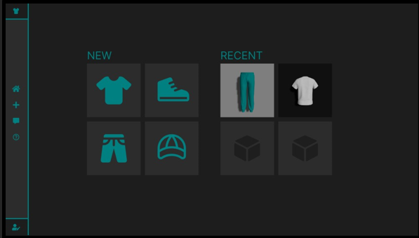

*Fig 1.1 SnX Create Page*

**VIII. Technology Stack**

React.js plays an important role in this process by making it easy to create reusable UI components. This allows developers to create dynamic, interactive user (www.coursera.org) interfaces that adapt to various user preferences and interactions. MongoDB is used as a data management system to support storage and retrieval of user data regarding clothing preferences, preferences, and selection options. Three.js is a powerful 3D library for creating realistic representations of clothing and accessories in a virtual environment. This tool allows users to view and interact with clothing choices in a realistic and immersive way.

**IX. Application Functionality**

The "3D Outfit Customizer" application offers users a unique and interactive shopping experience. Through a user-friendly interface, users can explore a virtual wardrobe containing a wide range of clothing items and accessories. They have the freedom to browse through various categories such as tops, bottoms, dresses, shoes, and accessories. Upon selecting an item, users can customize its color, pattern, and other attributes to match their preferences. The application leverages the power of Three.js to render these customized outfits in a realistic 3D environment, allowing users to visualize their selections from different angles and perspectives.

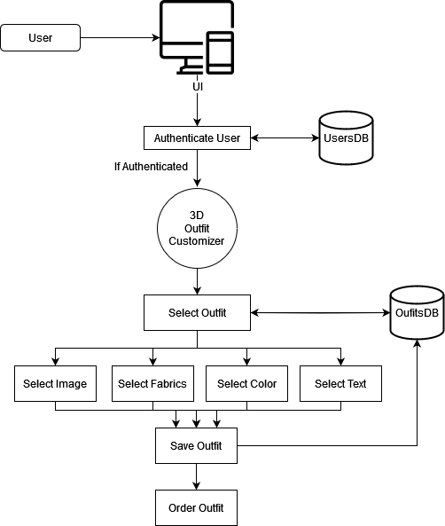

*Fig 1.2 System Architecture Diagram*

**X. User Experience and Future Enhancements**

By integrating Next.js, React, MongoDB, and Three.js, the "3D Outfit Customizer" project aims to deliver a seamless and engaging user experience that mimics the experience of shopping in a physical store. Users can explore a wide range of clothing options, customize colors, textures, and styles, and visualize their selections in real-time within a 3D virtual environment. Future enhancements could include the implementation of AI-driven recommendation engines to provide personalized outfit suggestions based on user preferences and browsing history. Additionally, the integration of social sharing features and augmented reality (AR) capabilities could further enhance user engagement and interactivity.

**XI. Seamless User Experience:**

One of the key highlights of the “3D Outfit Customizer” application is its seamless and immersive user experience. The integration of Next.js ensures fast and efficient page loading, while React components enable smooth navigation and interaction within the application. MongoDB handles the storage and retrieval of user data, ensuring that each user’s preferences and customized outfits are securely stored. The combination of these technologies results in a responsive and engaging platform where users can explore, experiment, and express their personal style with ease.

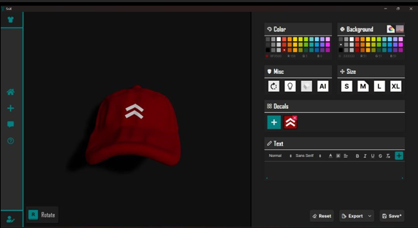

*Fig 1.3 Placing decals on Cap Model*

**XII. Enhancing Personalization and Exploration**

The "3D Outfit Customizer" application empowers users to experiment with different styles and combinations, fostering creativity and self-expression. By offering a diverse selection of clothing items and customization options, the application caters to a wide range of tastes and preferences. Users can mix and match various pieces to create unique and personalized outfits that reflect their individuality. Additionally, the immersive nature of the 3D environment encourages users to explore and discover new looks, enhancing their overall shopping experience.

**XIII. Strengths of the "3D Outfit Customizer" Project**

The "3D Outfit Customizer" project represents a significant advancement in online fashion shopping, offering users unparalleled levels of personalization and interactivity. By leveraging technologies such as Next.js, React, MongoDB, and Three.js, the application provides a seamless and immersive shopping experience. Users have the freedom to customize their outfits in a realistic 3D environment, enabling them to experiment with different styles and combinations. This level of customization fosters creativity and self-expression, enhancing user engagement and satisfaction.

**XIV. Limitations and Challenges**

Despite its strengths, the "3D Outfit Customizer" project faces certain limitations and challenges. One such challenge is the optimization of rendering performance, particularly when dealing with complex 3D models and high-resolution textures. Ensuring smooth and efficient rendering requires careful optimization techniques and consideration of hardware capabilities. Additionally, effective data management is crucial for storing and retrieving user preferences and customized outfits. MongoDB serves as the database for this purpose, but scalability and performance issues may arise with increasing user data and application complexity.

**XV. Considerations for Integration**

The integration of Next.js, React, MongoDB, and Three.js in the "3D Outfit Customizer" project requires careful consideration of compatibility and performance. While Next.js provides server-side rendering capabilities for improved page loading speed and SEO, react components facilitate the creation of reusable UI elements. MongoDB serves as the database for storing user data, while Three.js handles the rendering of 3D models in the virtual environment. In conclusion, the "3D Outfit Customizer" project demonstrates the potential of technology to transform the online fashion shopping experience. By leveraging Next.js, React, MongoDB, and Three.js, the project offers users a platform to personalize and customize their outfits in a 3D virtual environment. While further research and development are needed to address challenges and optimize performance, the project represents a significant step towards enhancing user experience in online fashion shopping.

**XVI. References**

1. React JS (Open Source JavaScript
2. Movie Data Visualization Based on WebGL - Min Li, Chunfang Li – 2021
3. Efficient visualization of 3D models by web browser - Bartosz Sawicki and Bartosz Chaber – 2013